Module 5 Assignment 1

Name: Sai Mrunaal Chatlapally

Class: 2022Fall-P-IFT458-IFT598-82341-82345

Date: 10-27-2022

**JAVA WEB TOKEN authentication flow:**

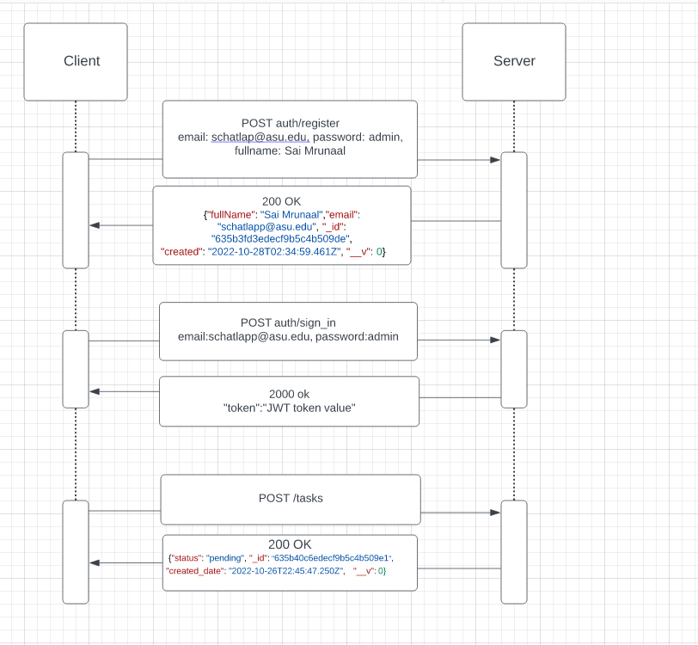

**Npm init**

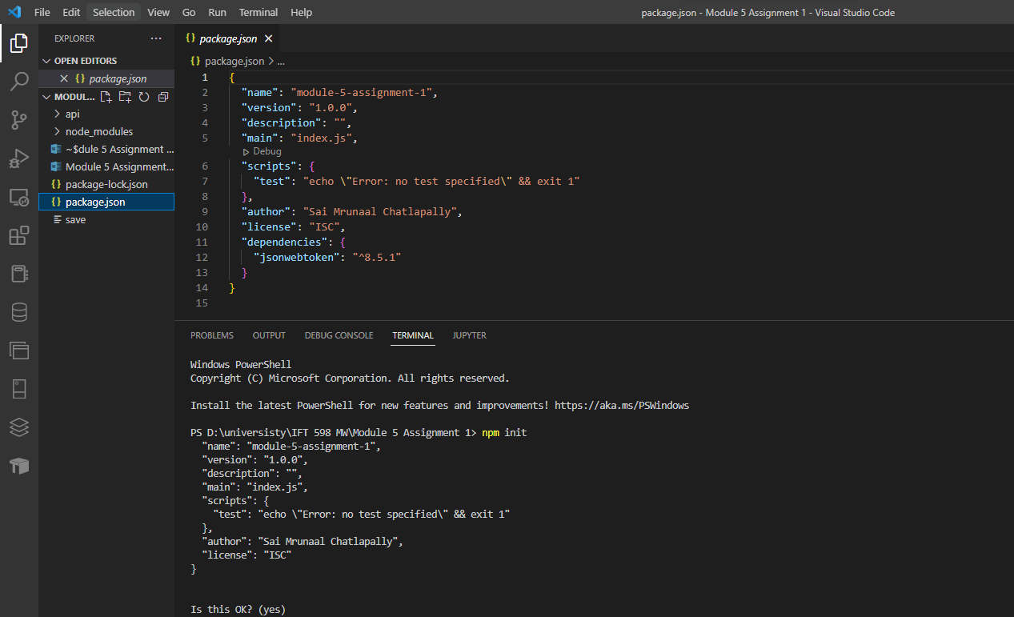

**Installing json web token package**

npm install jsonwebtoken --> save

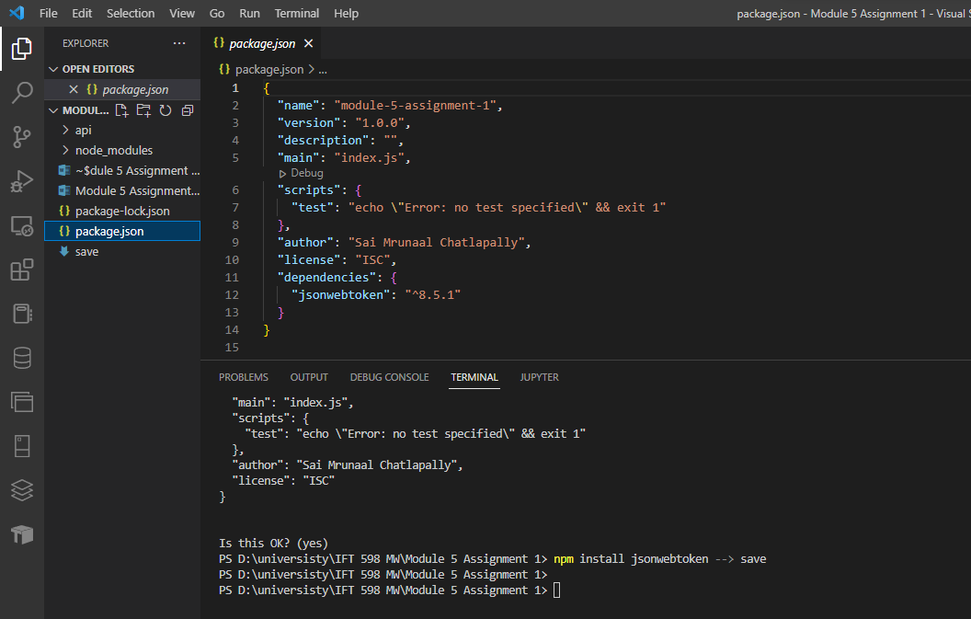

**Create user model**

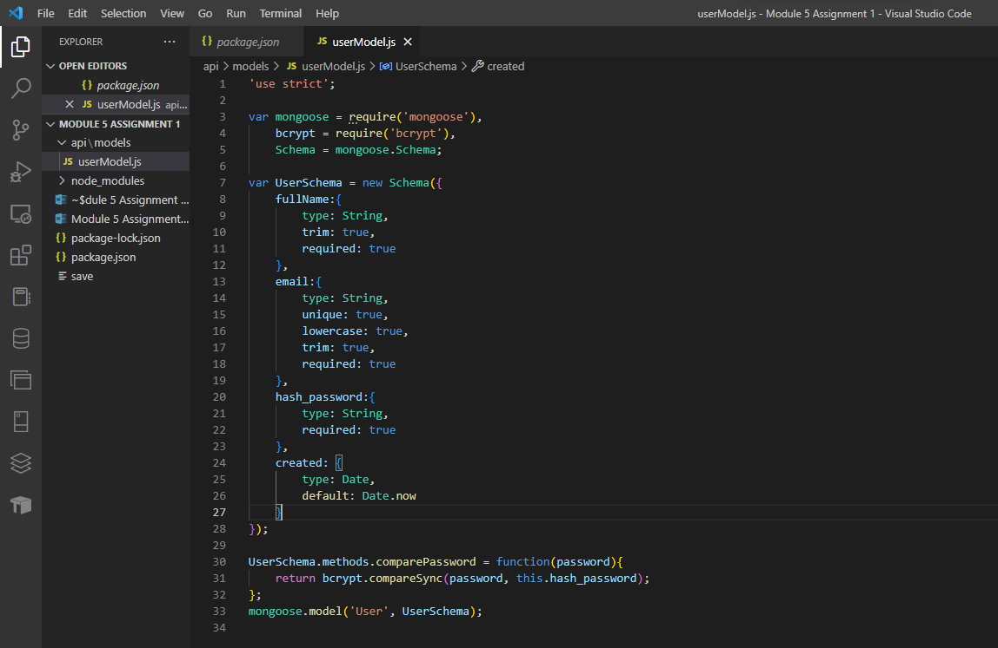

**Create user handlers**

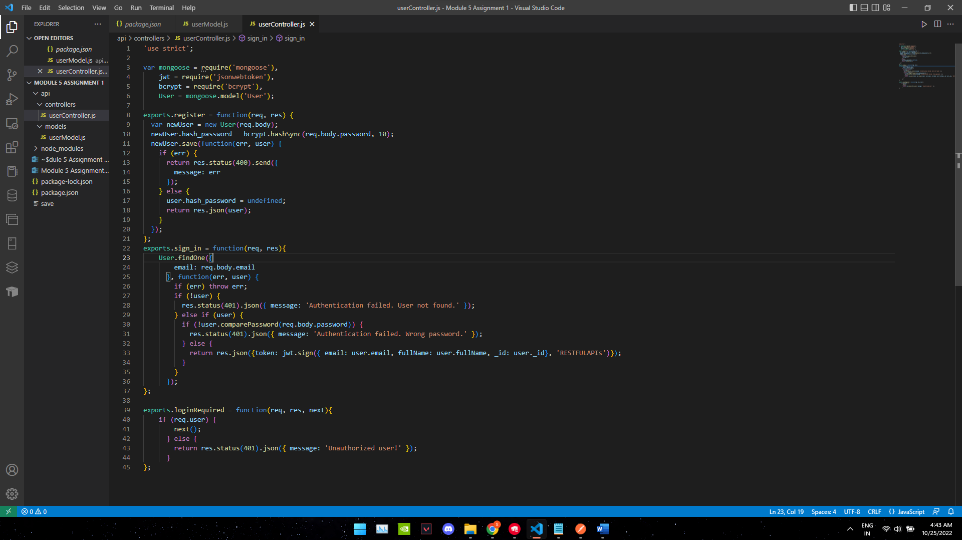

**Create user routes and update “/tasks” route:**

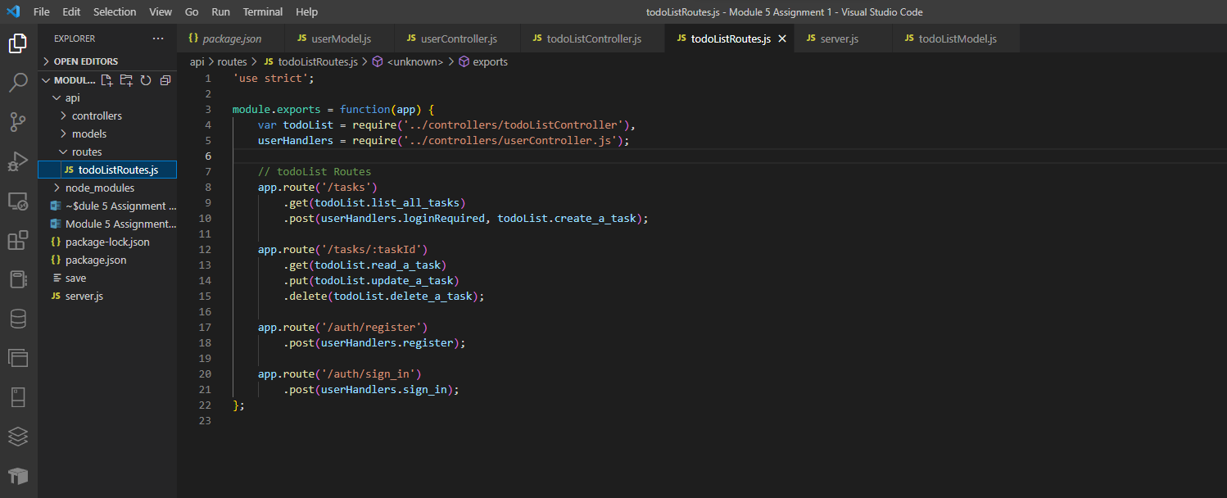

**Updating server.js:**

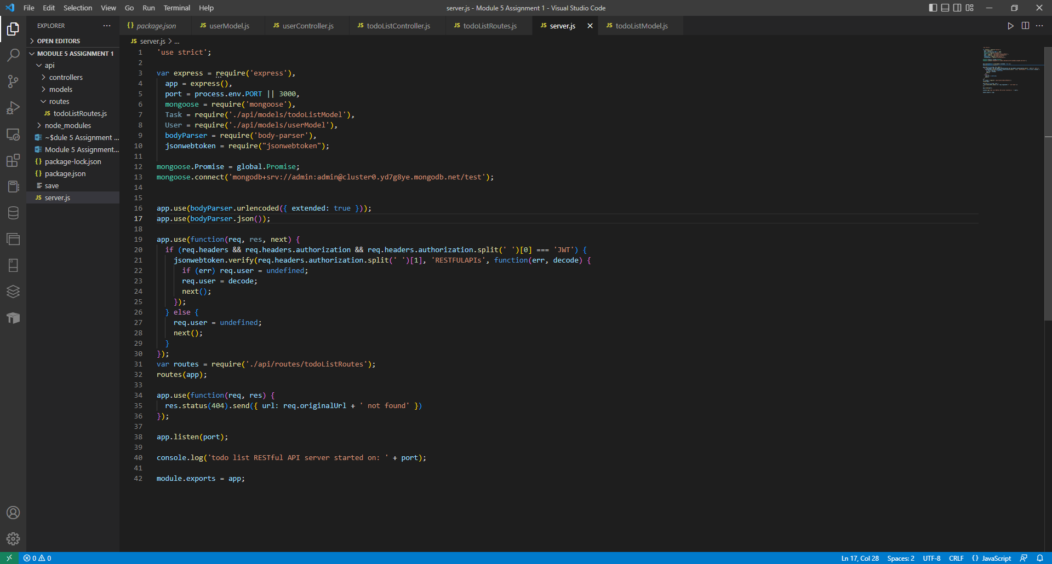

**Npm run start:**

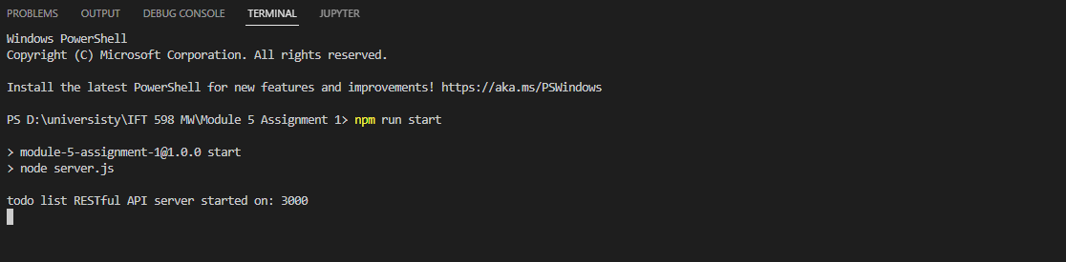

**POSTMAN:**

POST /tasks : With no authorization headers we get unauthorized user

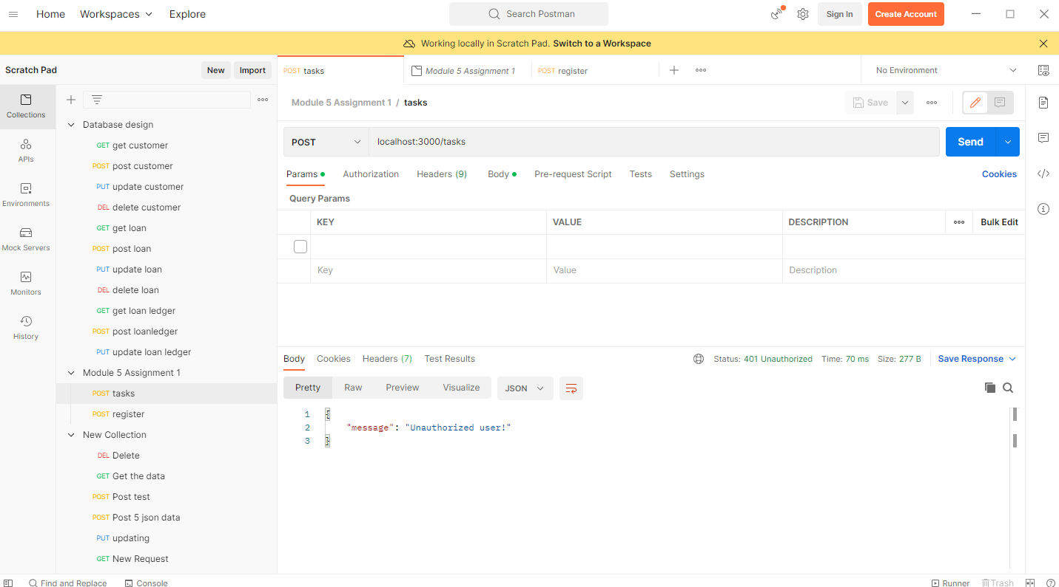

POST /auth/register : We register our user

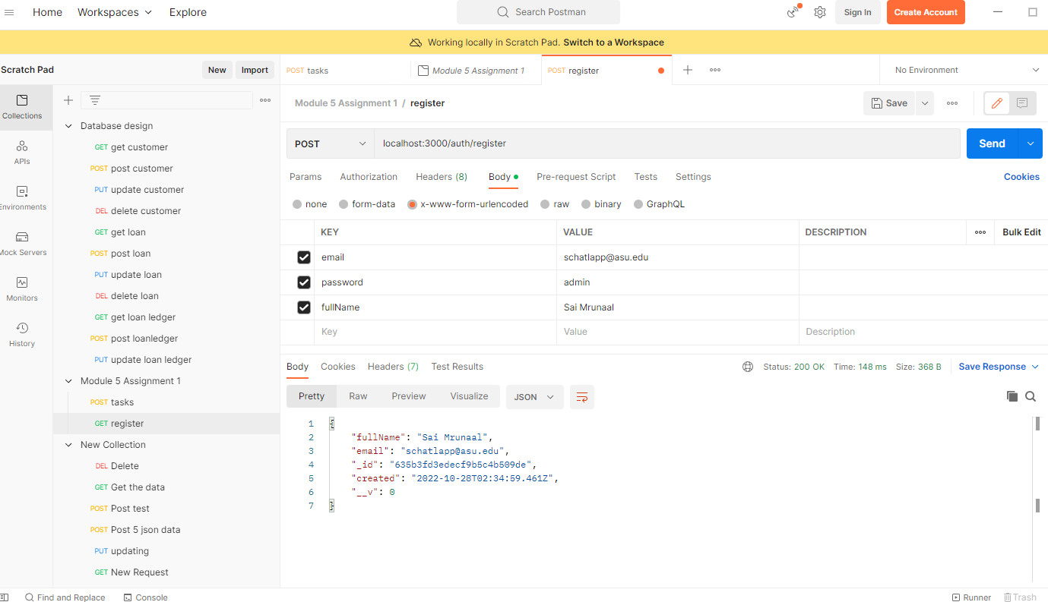

POST /auth/sign_in : Signing in our user to get out JWT token

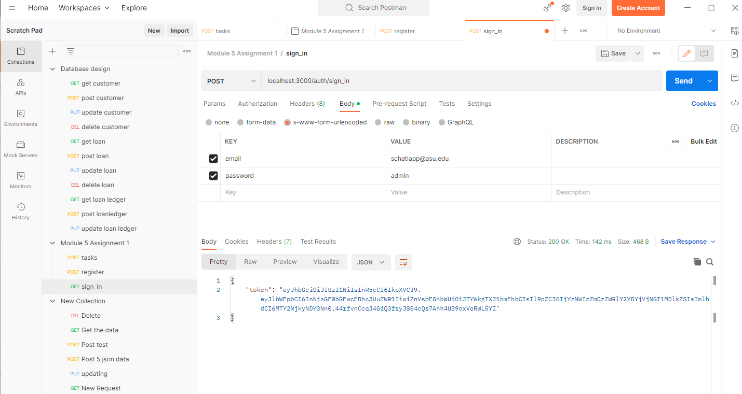

POST /tasks: We use our JWT token to authorize our request.

